**SysEng 6104 Project Task III**

**Inputs for Architecture Generation: Functional Architecture**

1. Based on your answer to question two and three in Project Task II define 5 fuzzy terms that can be used in assessing an overall system architecture. Define each of fuzzy term with 20-30 words. You can use the system selected to explain your definitions.

* Uncostly: the system can be produced using common materials and when expensive/specific products are suggested, cheaper functional alternatives will be used as replacements.
* Defined: the system will have sufficient traceability to verify the logic behind the design of each of the system’s components and the system as a whole.
* Reasonable Size: Considering the enormous size and expense of a full-sized asteroid mining system, the system will be a model scaled down to as small of a size as possible while still demonstrating the feasibility of the system.
* Durable: The system will stand up to shocks, space debris, Earth debris, and radiation without losing its functionality.
* Easy-to-Use: The system will interface with the user(s) in a way to minimize training time and demonstrate its capability.

1. Use OPM representation discussed in the text and class to build functional architecture for your system that covers at least three levels in internal functions like the example given below (Note the example given below is just a tree representation it does not use OPM). Since three levels are required you need provide sub-sub-functions for the sub functions provided in the figure. In your functional architecture you need to identify functions forms and operands.   
   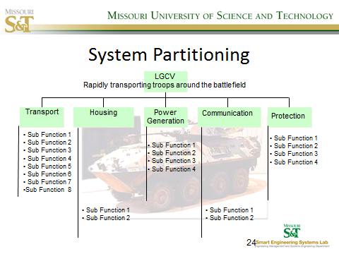

Define the following terms for your system with 50 words for each.

MOE – The clearly defined measures used to determine the overall performance of the system. The MOE’s must be phrased in a way so that they have specific, measurable goals. The MOE’s define what are baselines that can be used to determine what could be considered as a system that accomplishes its end state objectives. It assesses changes in system behavior, capability, or operational environment.

Examples for my system: speed of a certain radius-sized object that the system can capture, the shock in amount of G’s that the fully integrated system can withstand before losing ability to capture and transport objects, the distance the object moves in the system during simulated transportation speeds, the timeliness of communication with the system and its interfaces during simulated operations and downtime, and the preservation of the asteroid(s) during transport measured by mass lost after simulated transportation.

Operational/User Requirement: identify the essential capabilities, associated requirements, performance measures, and the process or series of actions to be taken in effecting the results that are desired in order to address mission area deficiencies, evolving applications or threats, emerging technologies, or system cost improvements. Defines what the user needs to know about the system in order to use it and not have any unaccounted-for factors coming into the picture.

Examples for my system: method of capturing asteroid using system, steps for maintenance

MOP – Measure of Performance: process of collecting, analyzing, and/or reporting information regarding the performance of a system. MOP’s quantify efficiency and effectiveness of systems. Measures of Performance quantify input, output, and performance dimensions of processes, products, services, and the overall system’s outcomes.

Example for my system: X minutes to capture the asteroid and X minutes to bring asteroid to containment within system

System Requirements: the configuration that a system must have in order for a hardware application to run smoothly and efficiently. Oftentimes, the system requirements includes a list of minimum system requirements and suggested/ideal system requirements.

Examples for my system: Processing power to either autonomously operate the system or interface with the system

TPM – Technical Performance Measure: key technical goals that need to be met because they are vital for the functioning of a system in its environment. It is a technique of predicting the future value of a key technical performance parameter of the higher-level end product under development based on current assessments of products lower in the system structure.

Example for my system: Stop rocks/asteroids going at X ft./sec to a speed of X ft./sec